**OUD Course Digest**

Overview:

This analysis breaks down the distribution of courses the 105 OUD BBA students have taken at UW-Madison since declaring an OUD major. 25 students started in Fall 2021, 47 started in Fall 22, and 33 started in Fall 23. The students’ course data was split up 3 different ways: course level, subject level and school level. As a caveat, this data only includes the courses students have taken after declaring as an OUD student. They may have taken certain courses for their degrees before joining the OUD program.

Key insights:

* On average, students are taking 16 credits of business courses total in contrast to 9 total L&S credits.
* Outside of the BBA, the top subjects that students are taking courses from are Philosophy, Economics, Psychology, Communication Arts and Mathematics.

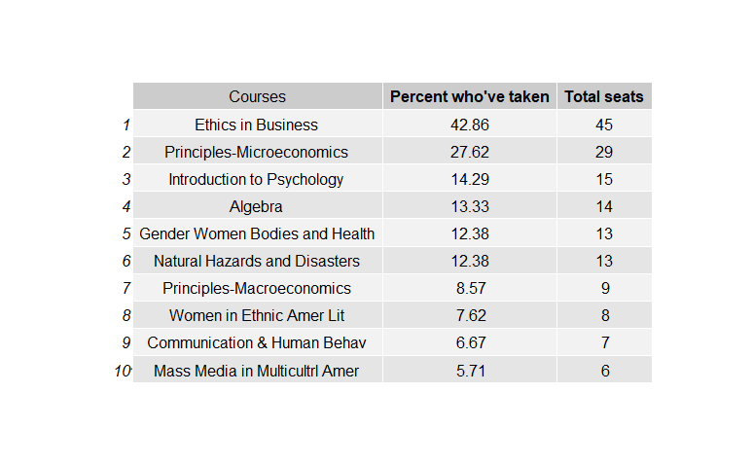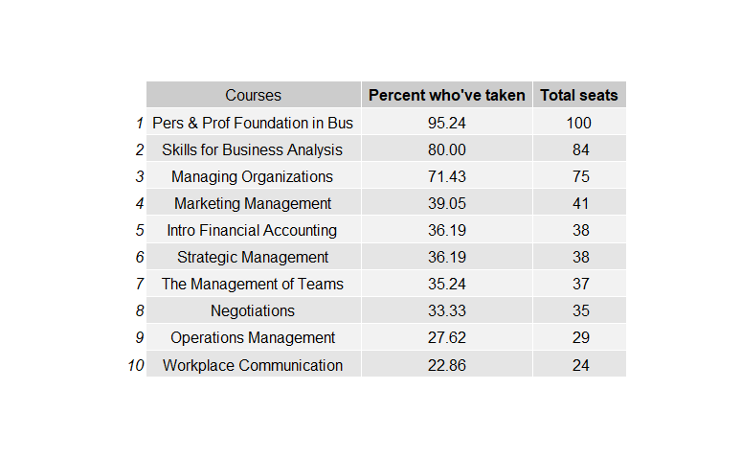*Figures 1 & 2: The table on the left is the most popular business courses taken by OUD students. The right shows the most popular nonbusiness courses.*

The data in these charts show the percentage and count of all 105 OUD students. Almost all students since declaring an OUD major across all 3 cohorts have taken PPFB. Skills for Business Analysis and Managing Organizations are close behind in total seat numbers, each with over 50% of students who’ve taken them. Marketing Management, followed by the rest of the classes in the table, is noticeably behind the leading three, where 64 of the OUD students haven’t taken it. The most popular non-business course taken is Ethic in Business, where a little under half of students have taken.

*Figure 3 & 4: The table on top includes all the subjects in the business school. The bottom table is the top 15 subjects from all other schools.*



The Avg courses taken column displays, for students who have taken at least one course in that subject, the average amount of courses they are taking in that subject. The Avg credits column is similar, displaying the average credit value of the courses taken in that subject, for students who have taken a 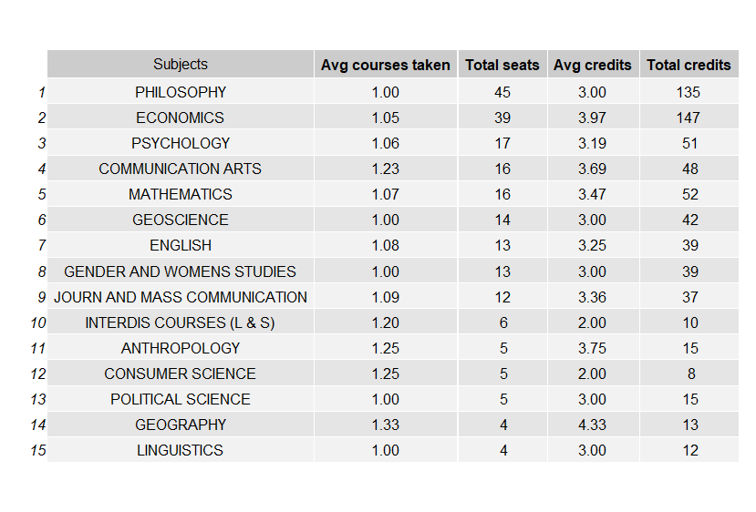course in that subject. Total credits provides the sum of all the credits taken in that subject area for the 105 OUD students, since declaring an OUD major. Lastly, total seats may include a student more than once depending on if they had taken more than one course in that subject.

Students take the highest number of courses from General Business, around 2-3 courses. Philosophy is the highest subject taken outside of the business subject areas. This is driven by the Ethics in Business course that 42.86% of OUD students have taken. Following is Economics, where 29 of those seats are from students taking Principles-Microeconomics.

*Figure 5: Table includes all the schools within UW.*

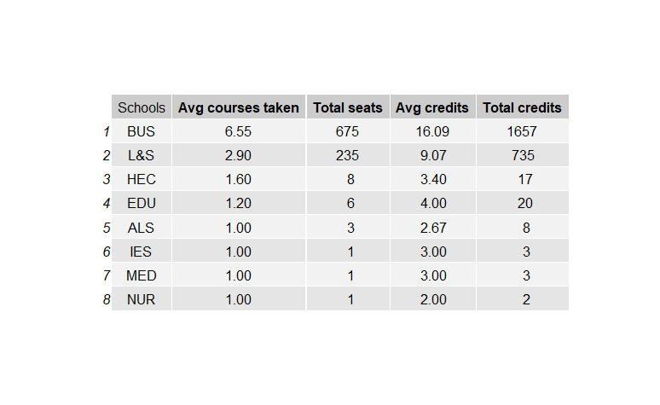Students take almost all their courses as an OUD student from WSB and the College of Letters & Science (L&S). The table above provides data for students who have taken at least one course offered by that School/College. On average, they have taken around 6-7 classes from WSB and 3 courses from L&S. Human Ecology are next, with around 1-2 classes per person for those that have taken a class offered by Human Ecology. However, the total enrollment of OUD students (8) is low compared to WSB and L&S.

*Figure 6: Count of OUD students who have taken classes in non-business subjects.*

The Total column (in gray) displays the total number of students in that cohort. This gives some explainability to why certain subject student counts are higher than in other cohorts. Overall, Philosophy and Econ, driven by the Ethics in Business Course and Principles of Microeconomics, respectively, are non-business subjects consistently enrolled in across each cohort. The remaining subjects are present in each cohort, but vary widely and could depend on requisites satisifed before a student declared the OUD major.